

Name/id: abdelkareem yousef mamdoh soubar/19110022

Assignment Title: systems Programming

Course Tutor: Dr. Ahmad Barghash

Submission Date: February 3, 2022

Part1

1-

i have been requested to create a management system for a phone shop, the system should be able to take the employees data in, and it should contain the data of the available phones in shop, this system should be capable of count the owners can do some delete, backup and searching for and all data tables are update able changeable plus editable which means the owner can add/ remove tables and edit them for future update.

The tables

employee(id, fname ,lname ,pos ,gender ,salary ,year ,month ,day ,char ,address)

phones (id, name, brand, color, price, count)

customer (id, name, gender, phone_number, year, month, day, email)

business use case

HR need to add employees to the employees table.

Employees need to the phone/ products to the phone table.

customer need to be inserted by the employees in to the system.

User Requirements:

1. A system that is able to save/store information from employees in the company

2. A method to able to search for any detail in the tables .

3. A security system that is based on editing file according to their permissions

4. Backing up files so no data will be gone.

5. view data from tables to check on them.

System Requirements:

1. add to write names and save them to files.

2. search function to search through data using the shell script.

3. Memory allocation (malloc)to make sure that we wont run out of memory.

4. backup through using sockets to represent server usage.

5. Multiprocessing (threads) is going to be used for doing the back up process.

OS:

The OS (OS) is computer code that controls all various programs on the computer when it is installed through the starting program. The application interface that initiates the service request will allow applications to access operations (API). Users can also communicate directly with the OS via a computer application such as a statement interface (CLI) or a graphical computer software (GUI).

Process:

A process is a type of computer virus that is created by one or more threads. Depending on the operating system (OS), the procedure may have numerous execution threads that finish directions at the same time.

w OS-controlled resources are shared among processes:

A remote entrance to the OS is considered an application, which is why we'd want associate degree API. So, what exactly is an associate's degree API? The API decides whether a developer should request a service from an operating system (OS) or another application. However, information is frequently transferred across services by requesting and returning the required information, as described in the API (Calling function). So, anytime an application requests anything from the OS, it must travel through an API to receive the resources it requires, and this is frequently how a developer obtains what he requires.

Asset use between processes is parted by the OS. Computer processor, memory, recording framework, organization, console, mouse, screen and various peripherals are regularly isolated by capacities. Subsequently, you'll have the option to run numerous cycles on a comparable machine. At the point when each cycles demand a comparable help, the bundle decides World Health Organization gets once, how much, and when. Memory the executives is that the capacity of the bundle to oversee conventional memory and move processes among memory and plate once wrapped up. Memory the board will follow all memory areas whether or not they are utilized by the technique or not. Operating system gives an extraordinary a piece of the memory to any technique that needs it, and various cycles can't get to that a piece of the memory that is have as of now got been given. A similar case is with the recording framework, the OS minds the honors of the technique to peruse/compose into a document and stop any 2 cycles to record into a comparative record along. Without the OS it'll be a bunch that can't fill in because of cycles don't comprehend that there ar various cycles except if they grant along. The administration from the OS isn't finished owing to that we tend to regularly see an accident report that break that the apparatus crashed owing to not having sufficient memory anyway much of the time that doesn't occur because of OS is sweet at its particular employment inside the most cases.

|  |  |
| --- | --- |
| Technique | Description |
| virtual memory | It is a memory management technique that enable the computer to make for the low sophistical ram storage by using the hard disk and it called swap storage  benefits :   1. the OS can run programs that are bigger than the ram limitation 2. it better in security because it requires mapping to keep the connection between the data in ram and sata storage. |
| multitasking | It is to run more than one program at the same time in the same computer which also uses all the computer devices at the same time and it better because it increases efficiency. |
| scheduling | Is the method that is used to assign and use the the resources of the computer hardware and it also controls the time memory and bandwidth of each processes/threads   1. use the components of the computer for as much as possible 2. it ensures the fairness in using the hardware components |
| policies | Given a specific task, the strategy refers to what needs to be done (that is, the activity to be performed), and the mechanism refers to how to do it (that is, the implementation to execute the strategy). In other words, the separation of mechanism and strategy is a design principle of computer science. It points out that the mechanism (those parts of the system that controls operation authorization and resource allocation) should not specify (or excessively restrict) policies, based on which decisions to authorize which operations and which resources are allocated. Please distinguish between policies and mechanisms. Strategy is the method of choosing which activities to perform. The mechanism is the realization of the execution strategy. |
| interrupt | In machine programming, an interrupt is a sign to the processor emitted via way of means of hardware or software program indicating an occasion that desires on the spot attention. An interrupt signals the processor to a high-precedence circumstance requiring the interruption of the modern code the processor is executing. The processor responds via way of means of postponing its modern activities, saving its state, and executing a characteristic referred to as an interrupt handler (or an interrupt carrier routine, ISR) to cope with the occasion. This interruption is temporary, and, after the interrupt handler finishes, the processor resumes regular activities. There are styles of interrupts: hardware interrupts and software program interrupts. |
| paging | On a very basic level, all coordinating tongues square measure programming vernaculars. The theoretical separation between the 2 is that coordinating tongues shouldn't for a second worry about the aggregation step and square measure rather taken. for instance, consistently, a program ought to be accumulated before running however by and large, a setting up language like JavaScript or PHP shouldn't for even a second should be organized.  Generally, organized activities run quicker than acknowledged undertakings due to they're beginning recuperate nearby code. Also, compilers scrutinize and take apart the code just the once, and report the bungles conjointly that the code may require, however the interpreter can examine and look at the code clarifications at whatever point it meets them and stops at that terribly model accepting that there's some error. In apply, the significance between the 2 is getting clouded in view of additional created estimation limits of the beautiful hardware and advanced committal to making practices.  Another motivation to be noted is that while describing a language as coordinating language or phony language, the natural components on that it'd execute should be taken into thought. the thinking why this is routinely major is that we will style accomplice interpreter for C language and use it as a setting up language, |

(2, 4, 5)-

as its shown in the diagram there is no component that can work with out the other one.

The user begins by using add then the would go tot he memory allocation (malloc) to keep the buffer open and not running out of memory then then user start giving input to the buffer which eventually uses the file processing system to write to a file.

In case the wanted to search, the search starts by using the buffer add up what the user wants to search for afterwords it gets feed to the shell script which has its own process to report back with the results of the search.

Delete starts by going to the search method and going through, so the user can see and check what line is the thing that we need to delete afterwords the sequence comes back to the delete function and then takes the user input for the line that is about to be removed then it feeds that line through the buffer to the to the shell script that will give the result of removing the line from the file.

Update starts by creating as buffer that contains a part of the shell script then the user inputs the required thing to search about then the script get feed and updates.

View is a really simple command called cat which displays what is inside the file.

Start server is a simple bash file that runes the script to compile the .c server file to start the server and launch it each time the user need to make backup he has to use the start server function

backup starts by running a thread to run the function backup the in side backup thread socket is used to communicate with the server and send it an indication signal that it should start backing up the tables and when its done it returns by saying that its done and for the server there is a log to under stand and know what is going inside the server.

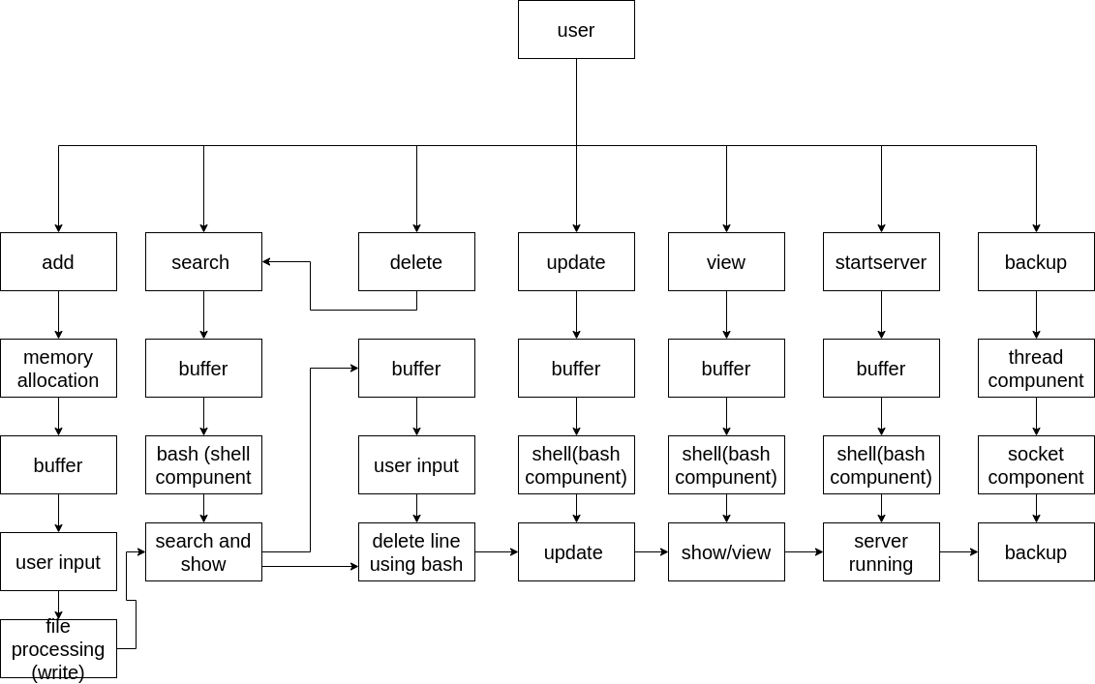

part2

1-in this system shell scripting is one of the main useful things that's been used, shell scripting was included in.

searching was made by using shell script and the command for is grep, to be able to search and access the files.

Deleting content from a file had never been easier when sed command comes in hand, in this program it was used to delete from a file by giving it the number of the line to be deleted.

Updating is using a shell script file to replace words in the table files, when running the script for search which is called replace.sh you need to give it the file name to access it and replace the work of your choice.

View is using shell by using the system command in c and this command gets given cat to show the content of a file in our case it show the data tables using cat.

staring the server uses a bash file to execute compiling and running a c file which represents the server side of the program.

backup on the backup server shell script was used in making copies of the tables to back them up

2-

Fundamentally, all prearranging dialects square measure programming dialects. The hypothetical differentiation between the 2 is that prearranging dialects needn't bother with the accumulation step and square measure rather taken. for example, regularly, a program should be gathered prior to running though generally, a prearranging language like JavaScript or PHP shouldn't for even a moment need to be arranged.

For the most part, arranged projects run faster than accepted projects because of they're starting recover local code. Additionally, compilers peruse and dissect the code simply the once, and report the blunders conjointly that the code might require, but the translator can peruse and examine the code explanations whenever it meets them and stops at that awfully example assuming there's some mistake. In apply, the greatness between the 2 is getting obscured because of further developed calculation capacities of the stylish equipment and progressed committal to composing rehearses.

One more reason to be noted is that while characterizing a language as prearranging language or fake language, the environmental elements on that it'd execute ought to be taken into thought. the reasoning why this is regularly fundamental is that we will style partner translator for C language and use it as a prearranging language,

3-

shell scripting made it easier for us to handle tasks that are related to os/system by enabling us to directly interact with the files and out cast most of what we do and what we need is system handling method that would make it easy to deal with for our user requirements we used shell scripting to make changes on the tables plus deleting from them and running other c program in addition to showing the content in side them and doing all of that without using buffers or read from c which in the end gave us better results in a more effective way to dealing with files and operating system related tasks.

part3

2-

Colorful tackle mechanisms modify resemblant calculation. the 2 most vital mechanisms area unit thread correspondence and vector community

•

Thread correspondence A medium for enforcing community in tackle employing a separate inflow of operation for every hand. Thread correspondence supports each regular and irregular correspondence, also as useful corruption.

•

Vector correspondence A medium for enforcing community in tackle exploitation an original inflow of operation on multiple knowledge corridor. Vector correspondence naturally supports regular correspondence still can also be applied to irregular correspondence with some limitations.

A tackle thread could be a tackle reality able of severally carnal discipline a program (a inflow of directions with data-dependent operation inflow) by itself. particularly it's its own “ instruction pointer” or “ program counter.” laying on the tackle, a core could have one or multiple tackle vestments. A software package thread could be a virtual tackle thread. associate degree software generally allows further software package vestments to live than there area unit factual tackle vestments by mapping software package vestments to tackle vestments as necessary. A calculation that employs multiple vestments in parallel is named thread parallel.

Vector correspondence refers to single operations replicated over collections of information. In study processors, this is frequently done by vector directions that act on vector registers. every vector register holds atiny low array of corridor. for case, within the Intel Advanced Vector Extensions (Intel AVX) every register will hold eight single- perfection (32 bit) floating purpose values. On supercomputers, the vectors is also for much longer, and will involve streaming knowledge to and from memory. we tend to contemplate each of those to be cases of vector correspondence, still we tend to generally mean the employment of vector directions once we use the term during this book.

part 4

2-

this system’s interface had been designed to cover over all system components plus we had in mind that how the system would be interacted with from the human side, which means while the interface was being built, the human friendly component was being thought about all the way through the project.

In our case that means that everything the user need to know is in the interface even at each input and output choices are displayed on the screen.